# Project Design Phase-I Solution Architecture

|  |  |
| --- | --- |
| Date | 31 October 2022 |
| Team ID | PNT2022TMID31454 |
| Project Name | News Tracker Application |
| Maximum Marks | 4 Marks |

**Solution Architecture:**

Solution architecture is an complex process ,with many sub-processes that the gap between business problems and technology solutions. Its goals are to:

* Find the best tech solution to solve existing business problems.
* Describe the structure, characteristics, behavior, and other aspects of the software to project stakeholders.
* Define features, development phases, and solution requirements to the project.
* Provide specifications according to which the solution is defined, managed, and delivered to the customers.

# Example - Solution Architecture Diagram:

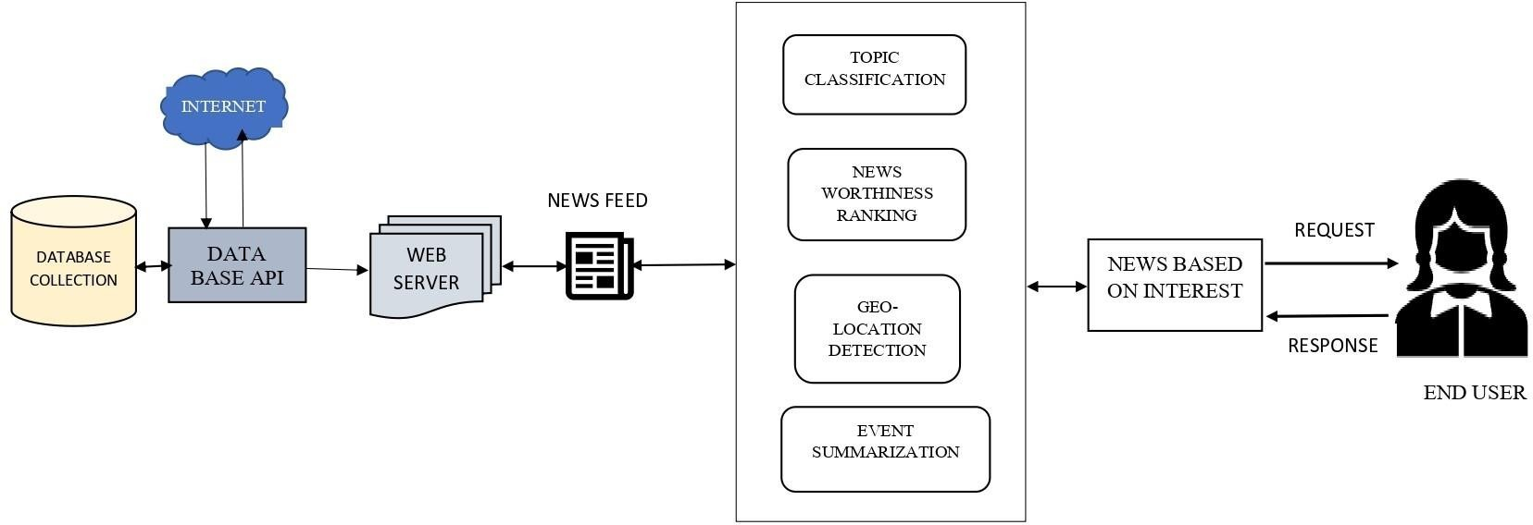

NEWS TRACKER APPLICATION